Born: 6
Gender: Male
Very religious
Migration date: early autumn 229

Personality:
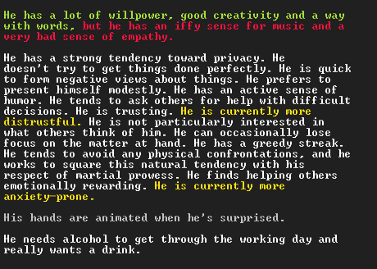
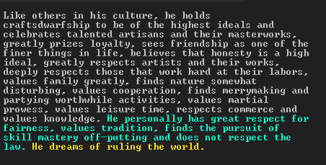


Position:
Currently messenger of Angrylashes (only on paper) – in reality works as an advisor to |the Mafol

Relationships:
Significant lover – Sakzul Fondledworks, killed by a Dragon in 78, had one child with Ducim
Mafol – ex-wife and former apprentice
Both parents died in 85
Third wife – Tirist Romancegilt, born 59, died of old age in 228 at Bootbegin, they met in 200 and married in 203, her mother was named Mafol
Eldest son – Onul Inkyglazes, 67-220
Only daughter - Zefon Craftplanks b. 68, basically an orphan since her mother died when she was 10, currently a diplomat
Two later sons – Unib Oiledspeaks b. 224 and Degel Walledtributes b. 225, currently with him as the only parent

